Chapter 2

E R DIAGRAM AND RELATIONAL SCHEMA DIAGRAM
Entity-Relationship Diagram
An entity relationship diagram, usually referred to as an E-R diagram represents the attributes, entities and relationships in a relational schema design.

Entity
Entities are represented by means of rectangles. Rectangles are named with the entity set they represent.

Attributes
Attributes are the properties of entities. Attributes are represented by means of ellipses. Every ellipse represents one attribute and is directly connected to its entity (rectangle).
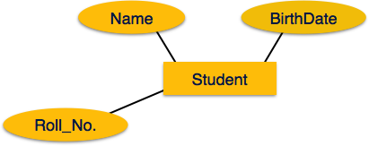

Relationship
Relationships are represented by diamond-shaped box. Name of the relationship is written inside the diamond-box. All the entities (rectangles) participating in a relationship, are connected to it by a line.
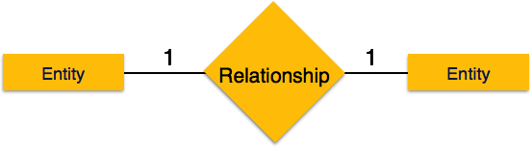
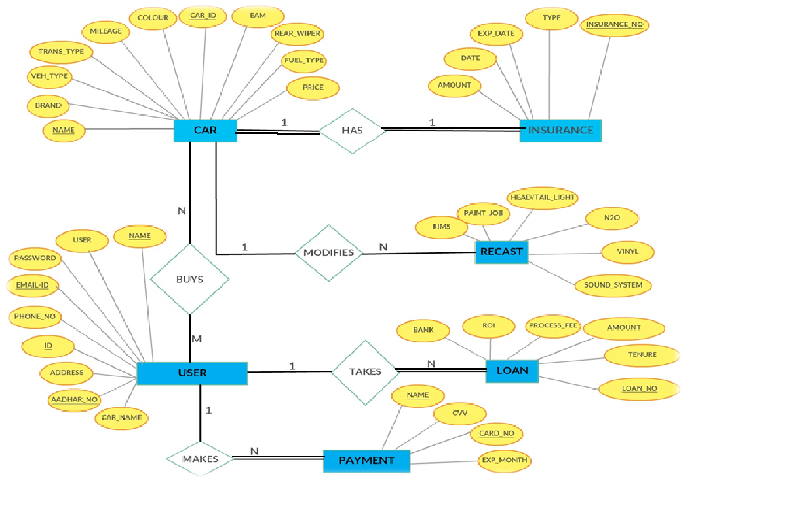
Fig 2.1 E R Diagram

The above figure 2.1 shows the Entity Relationship Diagram of the Car Trading System.

SCHEMA DIAGRAM
A database schema is the skeleton structure that represents the logical view of the entire database. It defines how the data is organized and how the relations among them are associated. It formulates all the constraints that are to be applied on the data.
A database schema defines its entities and the relationship among them. It contains a descriptive detail of the database, which can be depicted by means of schema diagrams. It’s the database designers who design the schema to help programmers understand the database and make it useful.
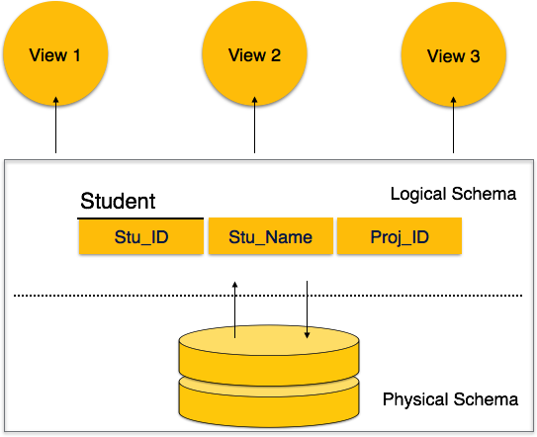
Fig 2.2 Logical Representation
A database schema can be divided broadly into two categories −
- Physical Database Schema − This schema pertains to the actual storage of data and its form of storage like files, indices, etc. It defines how the data will be stored in a secondary storage.
- Logical Database Schema − This schema defines all the logical constraints that need to be applied on the data stored. It defines tables, views, and integrity constraints.

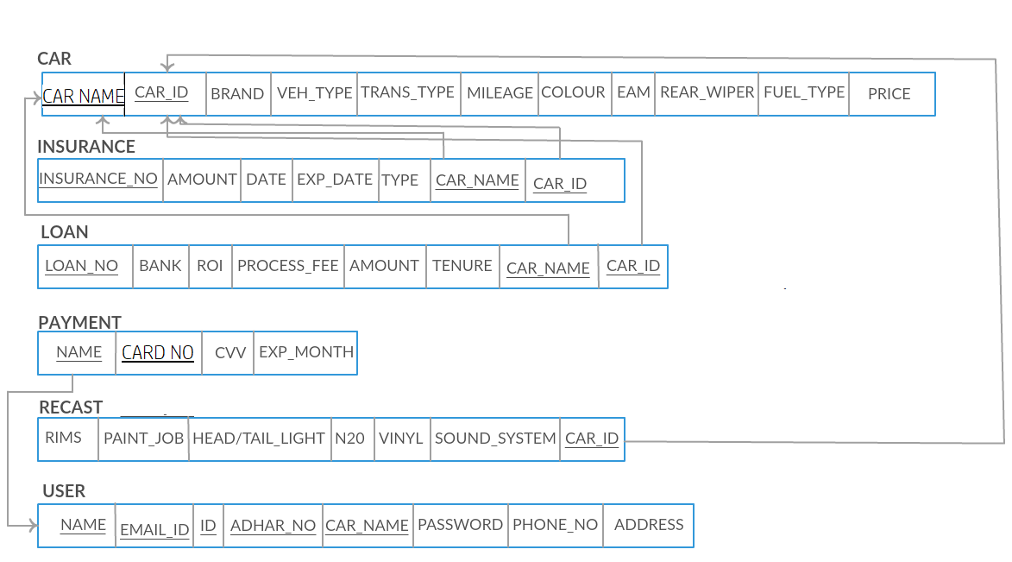
Fig 2.3 Schema Diagram
The above figure 2.3 shows the Schema Diagram of the Car Trading System.

